[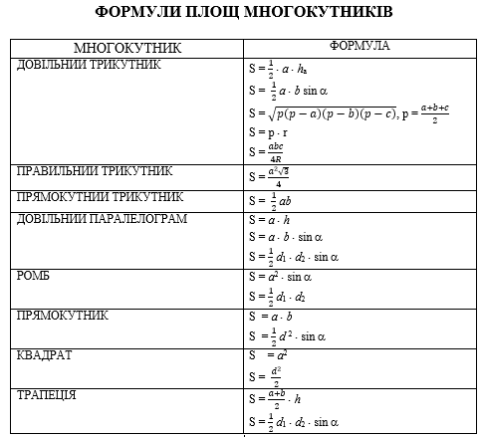](http://mathurok.com/wp-content/uploads/2015/09/ploshchi1.png)