|  |  |  |  |  |  |  |  |
| --- | --- | --- | --- | --- | --- | --- | --- |
| Час, год | 0 | 2 | 4 | 6 | 8 | 10 | 12 |
| Температура, °С | -3 | -5 | -6 | -4 | 0 | 2 | 7 |

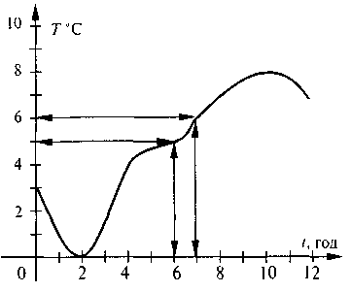 рис.1

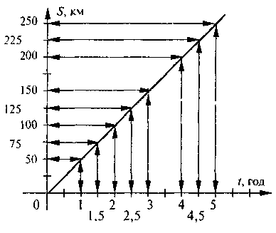

рис.2 рис.3

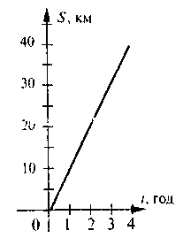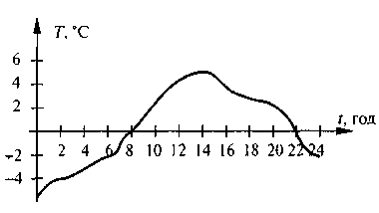

рис.4 рис.5

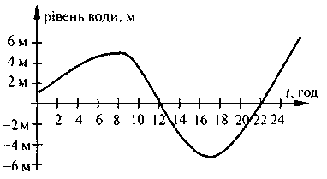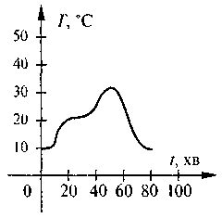

рис.6 рис.7

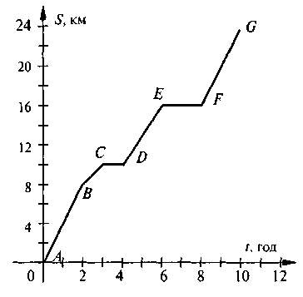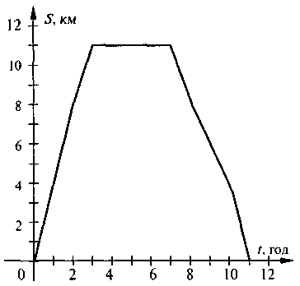

рис.8 рис.9